1. Open PPL Issue.lvproj:  
   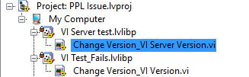
2. Run Change Version_VI Version
   1. It fails with error 1327 - LabVIEW: (Hex 0x52F) The specified NIIM is invalid for the current project.  
      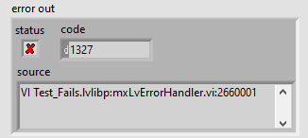
   2. The two get/set version Vis for build specs do not work when called from a PPL:  
      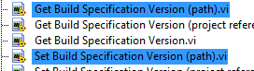
3. Run Change Version_VI Server Version it works as intended and can change the build spec version when in a PPL